David Garrett

**PREFACE**

I’m not going, to lie, I am better at criticism than I am with stating what I like, because things I don’t like stick out to me and things that I like just don’t.

**MAIN PAGE**

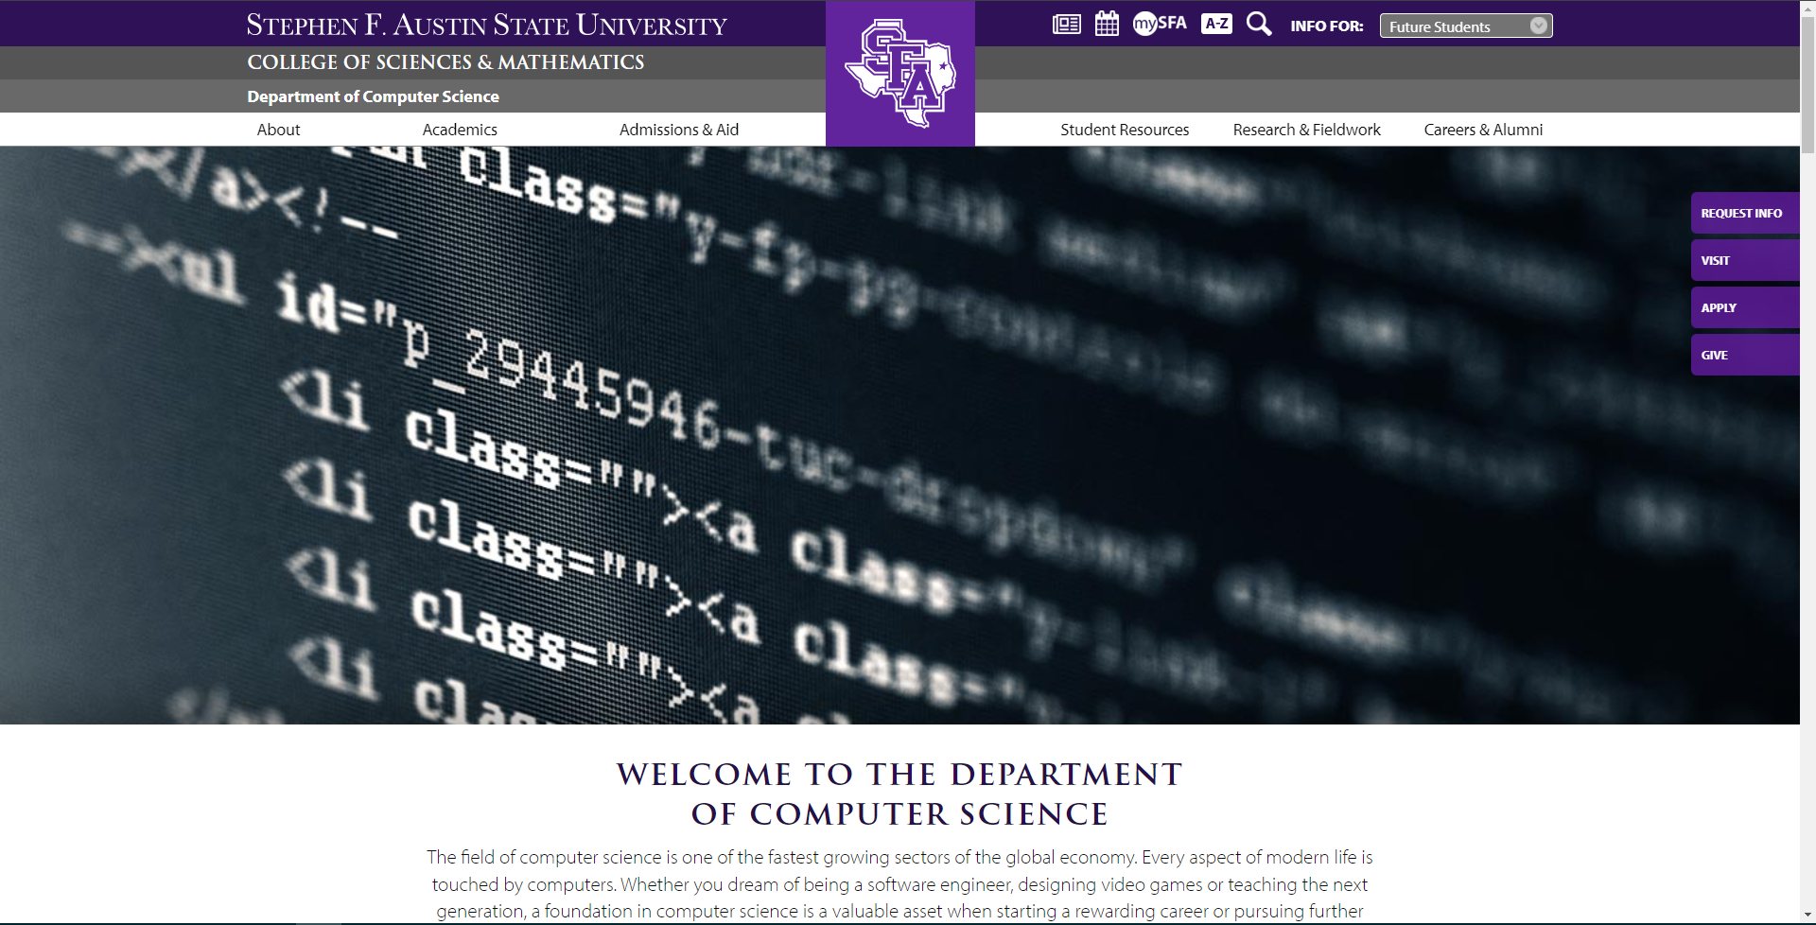

I like the picture with code at the top of this page, but I really wish that the banner above it would disappear as you scroll. Even if it could condense, that would be nice as well. That would allow for more information be shown.   
|

Another thing that stuck out to me was that designing video games and teaching the next generation were both listed as parts of the computer science department im the description. This makes no sense to me because I have not seen any classes that releate to either of these. As far as I know, there is not a single class that is related to game development in the computer science major, which is a little sad to me, since that is what I am doing, and I am using my minor in music to show that I have a wider range of capabilities, when core-curriculum classes could be doing this. In addition, “teaching the next generation” is just an education major, not a computer science degree, unless you are going for a doctorate, which would not be an undergrad major.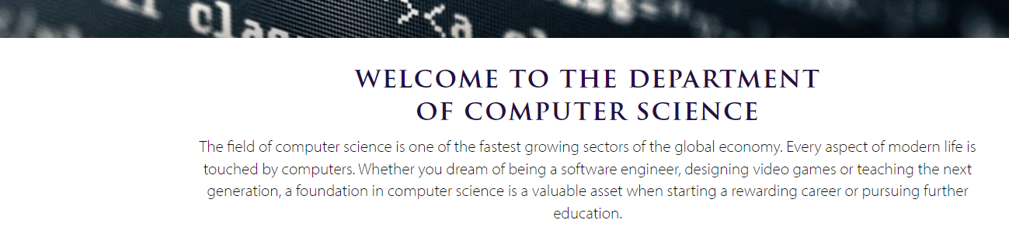

Another thing that I am not a fan of is the way that the areas of study are listed out. There is no sort of description about what they are unless you click on them. I think that for incoming freshman, and people who are considering the school should not have to open 3 extra tabs just to find out what all the majors are. It would be better if there was some sort of way that you could see the different majors compared to each other, whether that is a short explanation of each of them, a summary of the languages you learn, a rough description of the unique courses, a summary of the types of jobs attached to them or at least some other sort of way to distinguish them aside from their name and picture. I also think that there should be some sort of stronger separation for the masters degree and the undergraduate degrees.



On the next part of the home page with the lumberjack spotlight, there are only two options for the examples of successful lumberjacks. That is not a lot and makes it seem like there are not a lot of success stories. In addition, only one has even graduated. That seems like the program has not had a lot of successful alumni, or that the alumni are not loyal enough to the univeristy to do an interview, which would be another red flag for an incoming student. I also noticed that the arrows on the sides move up and down when scrolling between the two students. 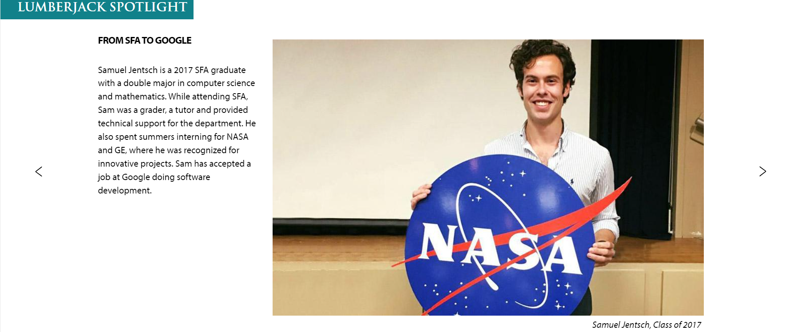

I think that the part about the computer science club is funny since I am the secretary, and at our last meeting we had only 10 people total show up. In addition, I have not seen many if not any Computer Science Department activities that all students in the department were invited to. I also find it a little bit difficult to swap between the descriptions of the two diferent pictures. I wish there were tabs that let you swap between them more easily, or areas you could hover over to swap directly without having to wait a few moments hovering in the white space, in order to reset and swap the picture. 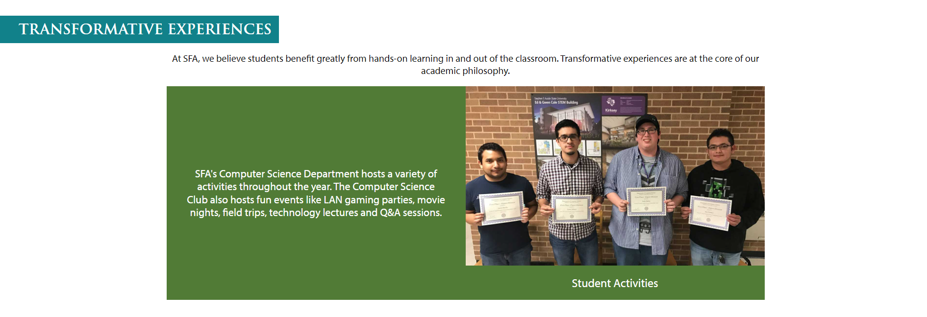

All of these students graduated in the spring of 2021, and are no longer SFA students. 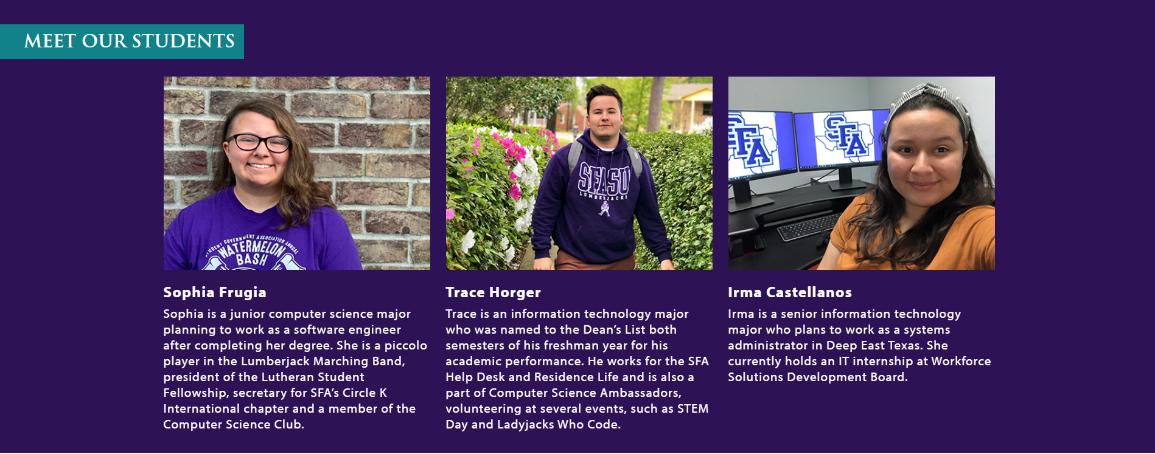

Overall, on the home page, I noticed that between a lot of the different portions of the page, there were just gray lines and white backgrounds. I feel like it could be much more dynamic and easier to look at, as well as navigate. It may also be good to have a sort of persistent menu on the left that does not move when you scroll, which can have the titles of the different sections, and scroll you to the specific sections you click on.

Also, there seemed to be little consistency with the font. A little bit more regularity may be a good touch. It may even look cool to incorporate a popular programming font somewhere on the page.

**Rachel Rucker Article**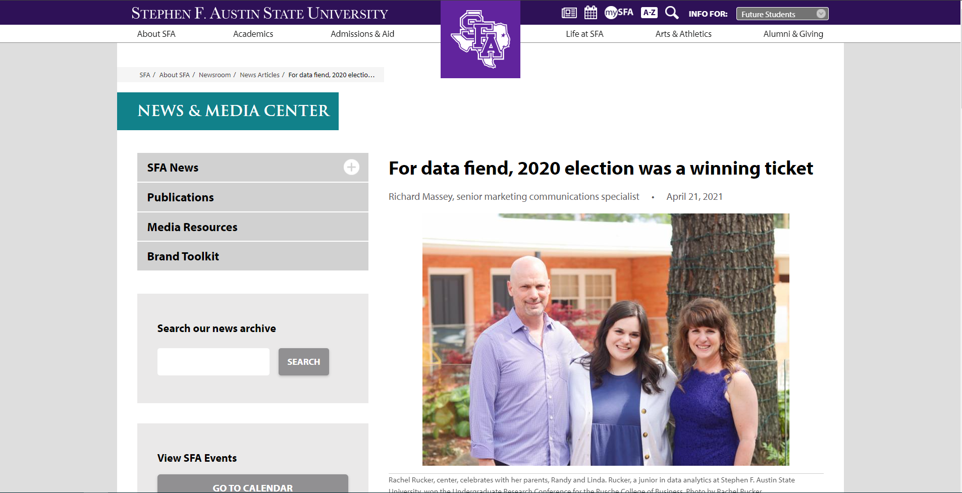

Overall, I thought that this article was fine, but there is a large amount of unused space on either side of the article, and there menus on the left are sticking out a lot more than I would expect. It makes the article seem like it is not the main focus of the page, because of how much it sticks out.

**Clubs & Organizations**

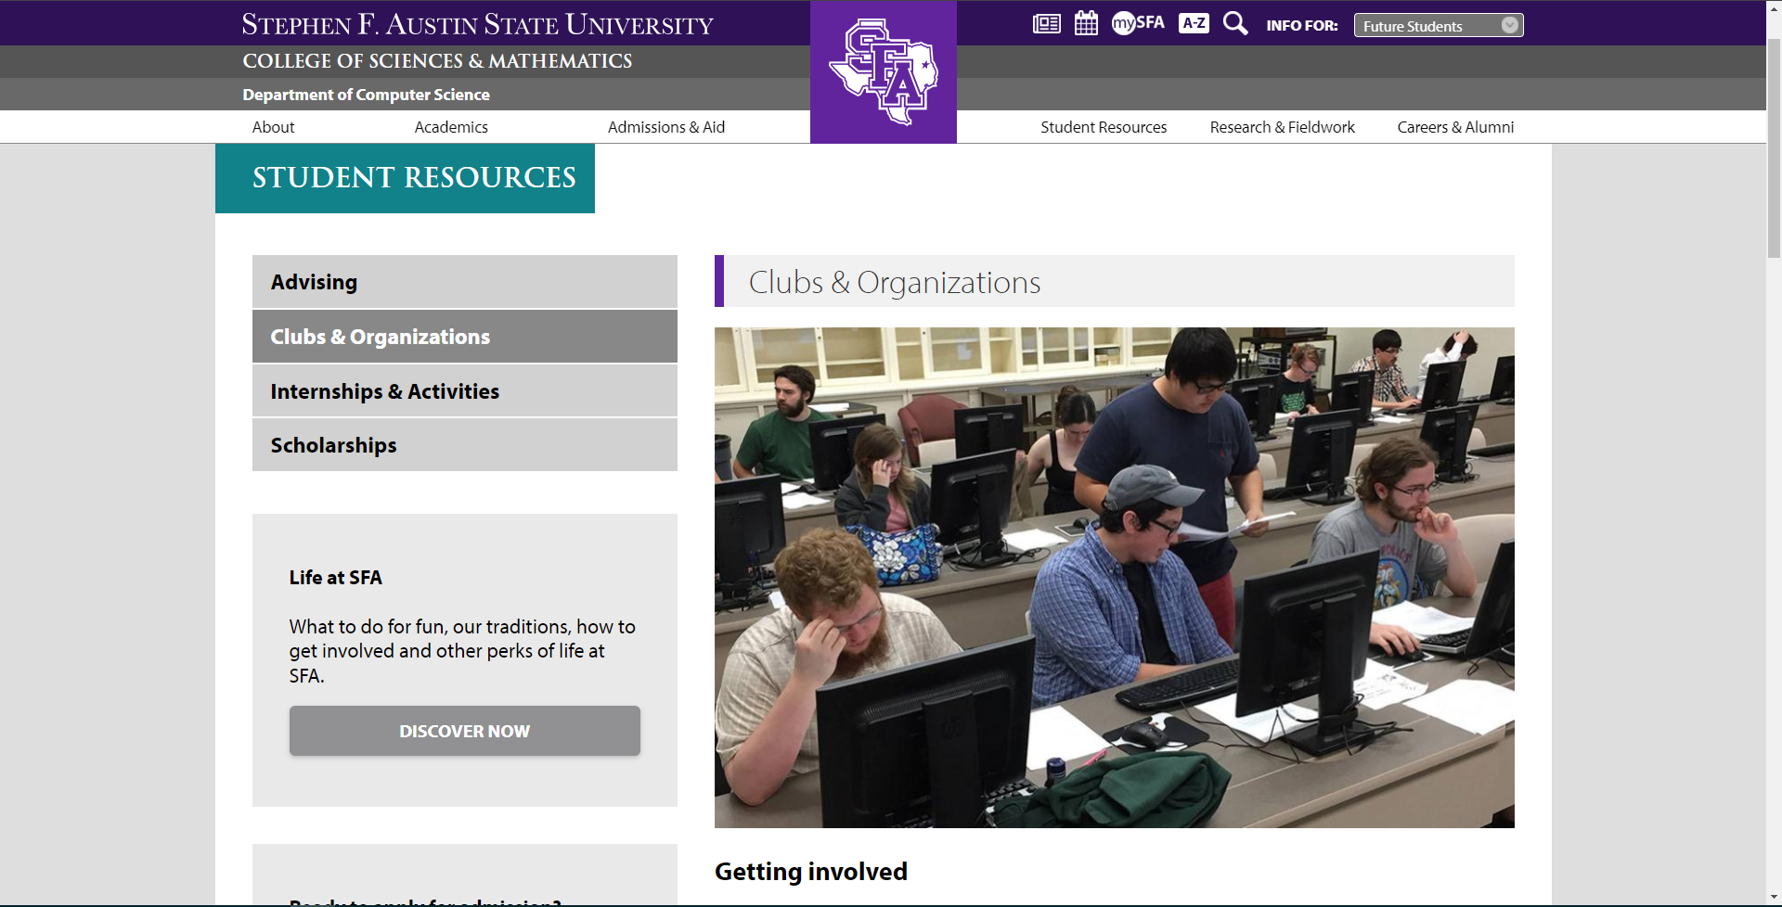

This page suffers from a lot of the same issues that the article, but it just feels like its not terribly a good look on the department. The fact that there is a whole page for clubs and organizations, and there are only two just kind of looks bad.

**Advisory Council**

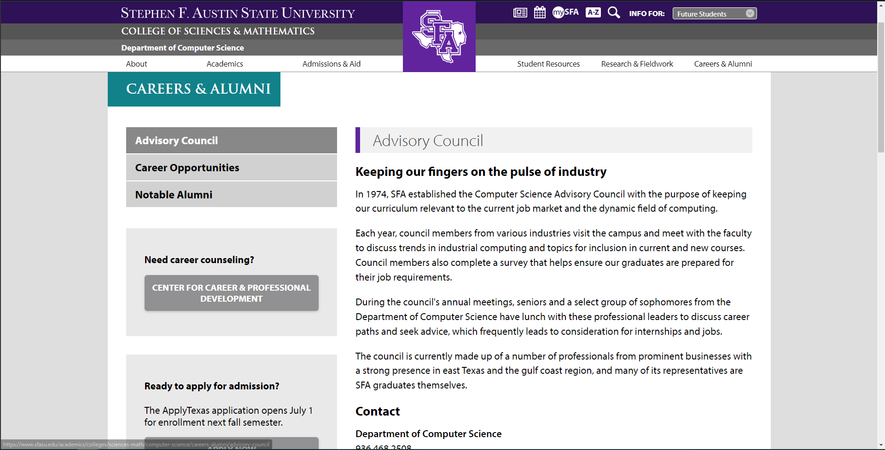

I think that this page is a little disingenuous because all of the opportunities for students to benefit from this council are whitelisted with only a select number of students invited. In addition, some of the companies that are represented are not even states from Texas, such as SciCom, which is located in Virginia.

**Internships and Activities**

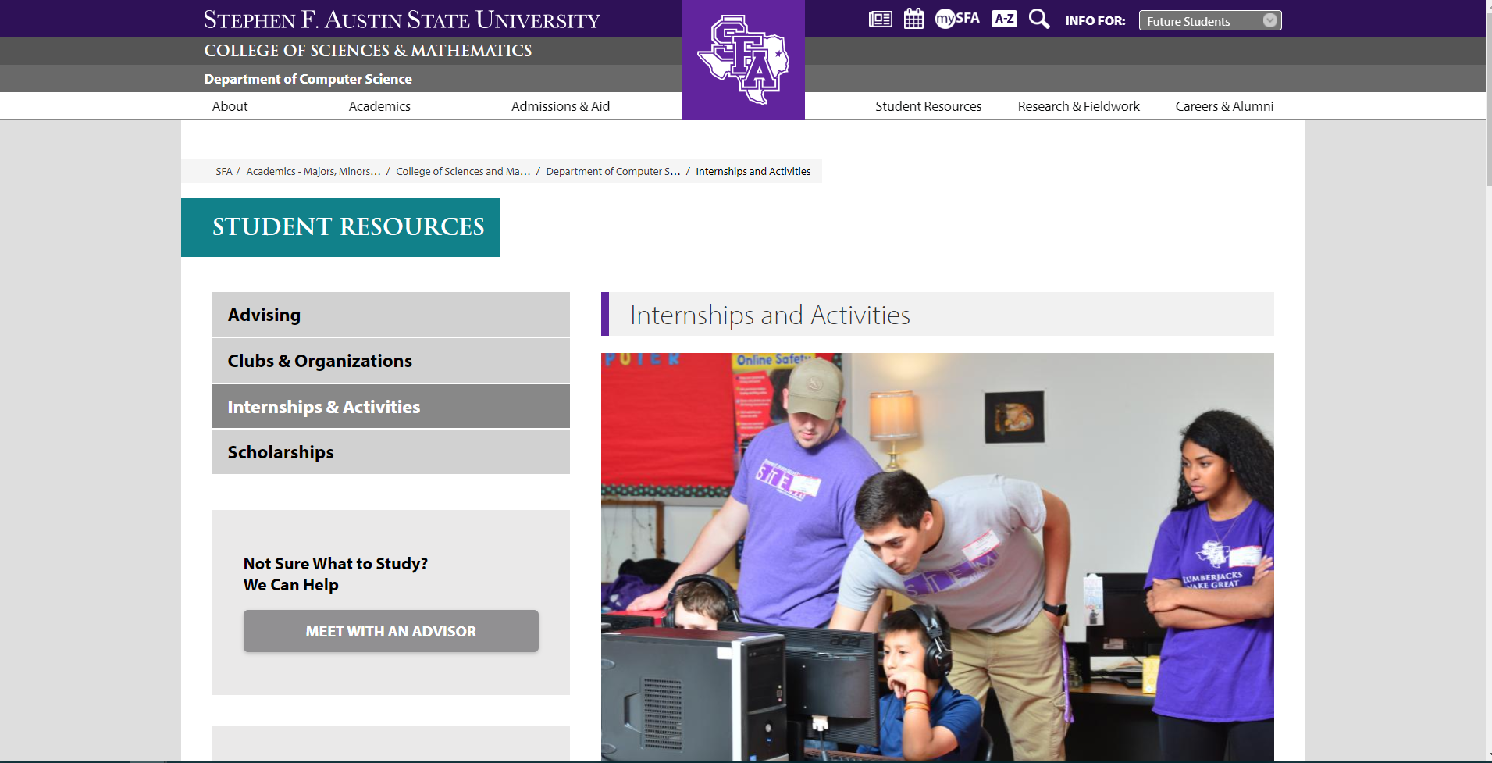

I feel like this page is a long explanation which is basically boiled down to saying that if a student can get an internship, then they can get class credit for it (on the old system, I don’t even know if it is still a class that exists on the new system). The information about the computer science club and the programming contest are once again re-stated.

**Conclusion**

Overall, I think that the website has a lot of out-of-date information and is very misleading about the resources available for the general student base. The CS Club is hardly much of a club now that there are separate games clubs and esports clubs, and with the lack of resources we have to actually do stuff. There is not a lot of resources for students to get internships out of college, other thant he select few who are invited to meet with the advisory council.

The UI at the top is large and takes up a lot of screen space, and does not condense or dissapear. There is a lot of blank space on the sides which is just gray. The menus on the left stick out a lot, and do not follow the user while scrolling. There are not a lot of tools to navigate the site that are easy to follow, and some bits of the information could be presented better, such as the way that the majors are described and shown off.

I did not intend for this to be as scathing of a review as it turned out to be, but I think that there are a few things that could be improved up in both the website and the department.